4.6 ANSWERS TO EXERCISES

4.6 Exercise 1

1. a) Benzene is a flat six-membered ring of six carbon atoms
Each carbon atom is bonded to one hydrogen atom and two other carbon atoms. The angle between all the bonds is 120º.
The fourth carbon electron is delocalised: all six spare p-orbitals overlap and the six electrons move freely within the overlapping orbitals.
b) The delocalised electrons give stability to the benzene molecule that normal “double bonds” do not.
Addition reactions break the delocalised ring, so are not favoured.
2. a) nitrobenzene
b) methylbenzene
e) methylethylbenzene
d) phenylpropanone
e) phenylamine

3. a) H₂SO₄ + HNO₃ → H₂NO₃⁺ + HSO₄⁻
H₂NO₃⁺ → H₂O + NO₂⁺
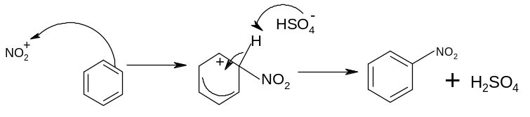
b) R-Cl + AlCl₃ → R⁺ + AlCl₄⁻
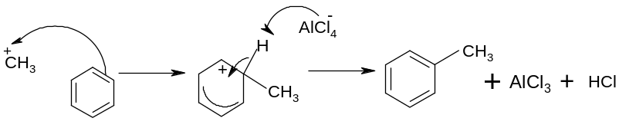
c)
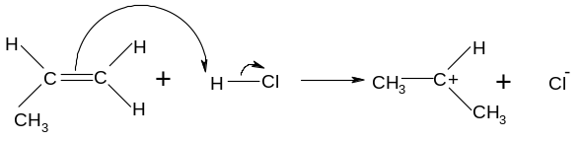
AlCl₃ + Cl⁻ → AlCl₄⁻
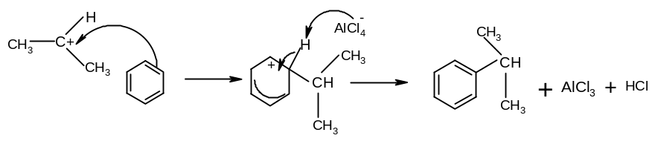

d) C₂H₅COCl + AlCl₃ → C₂H₅CO⁺ + AlCl₄⁻
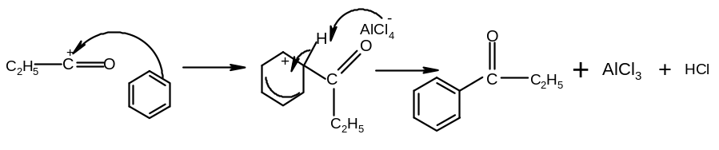
4. The lone pair on the N
is drawn into the delocalised system
so is less available for bonding with a proton

5. a) used in the manufacture of explosives
b) used in the manufacture of dyes
c) used in the manufacture of polystyrene

